Teaching materials

Sekundarstufe II

“The 25th Annual Putnam County Spelling Bee”

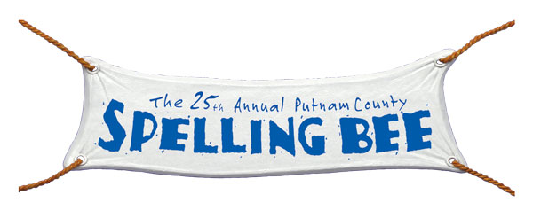

What is a spelling bee?

A spelling bee is a competition in which the participants are asked to spell a huge variety of words with increasing difficulty as the contest progresses. It is won by the individual or team who spells the greatest number of words correctly but as soon as a contestant misspells a word he or she is eliminated from the competition. The spelling bee originated in the USA but it has emigrated to other countries, even to Germany, due to the famous documentary "Spellbound" from 2002.

Content of the musical

The musical “The 25th Annual Putnam County Spelling Bee” is a comedy - play which deals with a fictional spelling contest - the spelling bee. This contest takes place in the Putnam Valley Middle School and is performed by a group of 6 outsiders who are determined to win the spelling competition for various reasons. During the bee the participants express their hopes, passions and struggles in several jocular, touchy and catchy songs. Puberty, friendship, love, politics, sexuality and many more relevant topics in society are part of the musical. For this reason the musical is relevant for the Abitur topic “The Individual and Society”.

Main Characters

Chip Tolentino

Chip is an athletic, social, boy scout and the champion of last 24th Annual Putnam County Spelling Bee. As a motivated participant he wants to defend his at this year’s spelling bee but unfortunately he finds puberty hitting at a really inappropriate moment.

Logainne "Schwarzy" SchwartzandGrubenniere

Logainne is the youngest speller of all and on top of that she is the most politically aware since she often brings up current political figures. Her family situation is out of the ordinary- she has two gay fathers from whom she has her combined last name. The young lady is a person who is driven by external and internal pressure but above everything she has the desire to make her two fathers proud. To the amusement of the audience she speaks with a lisp which creates very amusing scenes during the play but also expresses how uncomfortable she feels in her body.

Leaf Coneybear

Leaf never expected to compete at the competition. Everything at the Spelling Bee is an adventure to him because he was home-schooled by his parents whose ancestors were former hippies and who have an overprotective personality. His mother even pleads with Leaf to wear his protective helmet at the competition. In fact, he suffers from severe Attention Deficit Disorder (ADD). He never expects to win - or even to spell one word right.

William Morris Barfée

William is an obese kid who bullies other kids in order to avoid being picked on. His parents are divorced and his father has since found a younger woman. William does not expect kindness from anyone but his mother and as a result he is rather a loner and doesn’t have friends. In fact he never expected to care about someone else than himself, but during the play he develops a crush on Olive.
William was the finalist of the spelling bee last year. He had to be eliminated due to an allergic reaction to peanuts. He now wants to win the 25th Annual Putnam County Spelling Bee. Therefore he has developed a special method of spelling - “the magic foot”.

Marcy Park

Marcy is a transfer student from Virginia. Despite the fact that she was placed ninth in the last championship she is very confident about winning the local competition this year. Marcy is a poster child of the Over-Achieving Asian – her parents expect only excellence – and in addition she assumes that God also expects precision.
Not only is she a good speller but also a member of all-American hockey. She is a championship rugby player and is able to play Chopin and Mozart on multiple instruments. Marcy is a person who sleeps only 3 hours a night, hiding in the bathroom cabinet and is really tired of always winning. She attends a school called “Our Lady of Intermittent Sorrows” and isn’t allowed to cry.

Olive Ostrovsky

Olive is a complete newcomer to competitive spelling. Her mother lives in an ashram in India and her father works late so Olive spends much of her time being alone at home, which leads to her reading many books. Moreover the words she finds in the books give her much comfort. Her “friend” (the dictionary) is helping her to make it to the competition. Olive is an enormously shy person but during the play she slowly starts to warmup.

Exercises

1. Read the texts about the background of the musical from above.

2. Imagine that you’re one of the participants of a spelling bee. What are your fears and emotions concerning the competition? What are your weaknesses and strengths? Do you have any special strategies? What makes you different from other spellers? Write a text of at least 200 words. After finishing your text, find a partner and read your text out loud. Compare them and discuss your texts.

3. Listen to the following song and fill in the gaps.

My favorite moment of the bee

MR. PANCH Will the final two spellers please step forward.
MS. PERETTI Oh boy and Oh girl only two remain. I feel joy but I also feel pain
because I know what’s coming. Joy never comes for free. In a
moment he or she will enter spelling history, feeling triumph and glee.
In this moment of perfect __________I hear triumphant sounds of
timpani. It’s my favorite moment of the bee!
MR. PANCH Mr. Barfee, "________________."
WILLIAM Corzya.
MR. PANCH "Ilspile."
OLIVE Ilspile?
MR. PANCH Zoonosis._________________. Astrobleme.
OLIVE I'm loving every minute
WILLIAM Astrobleme.
OLIVE Who knew I had this thirst?
WILLIAM A-S-T
OLIVE To think that I might win it is _____________news and I'm about to burst
WILLIAM R-O astro
OLIVE How wonderful it feels to stand so close to first
WILLIAM B-L-E
OLIVE I'll make it happen and not as previously reckoned cause I will not come in
second! I hate to come in second. Yes I do! Yes I do! Yes I do! Yes I do!
I will not come in second.
WILLIAM M-E. Astrobleme
MR. PANCH That is correct. Miss Ostrovsky spell "____________________"
WILLIAM Am I a Red Socks or a Yankee? Who will come in second? People are
scared of me and no one really likes me. I won't come in second. Hey Olive,
don't think I'm distracted by your eyes and your smile and your hairdo. Oh
the things I do not dare do; my fears are odious and fecund. You will not
outrank me. I won't wave my hankie. Second! I won't come in second! I won't
come in second! I won't come in second!
OLIVE I won't come in second. I won't come in second. I won't come in second.
Second. Elanguescence E-L-A-N-G-U-E-S-S-E-N-C-E? Elanguescence?
MR. PANCH For the win, William your word is: "_______________________"
WILLIAM Yes of course, Weltanschauung. W...E...L...T..A...N...S..C..H..A...U-
CHORUS Who will come in…? Who will come in…? Who will come in…?
WILLIAM You
OLIVE I feel I'm in my glory
WILLIAM Should I come in second?
OLIVE Mama I made a friend
WILLIAM But should I come in second?
OLIVE I'll lose and that's the story,
WILLIAM Is second for me?
OLIVE But we are equals Ma where neither ________________
WILLIAM My fears are odious and fecund
OLIVE I am. I am fine with second. I can live with second. Yes, second. I will come
in second
WILLIAM And should I throw the bee? Could be ________________any second.
Yeah, would I be happy second? If foe ever ever ever to always be stuck in
second. Will I come in second? Will I come in..? S-C-H-A-U
OLIVE It's alright, Barf.
WILLIAM U-N-G. Weltanschauung
MR. PANCH We have a winner!
CHORUS Champion!!
RONA Just sensational
CHORUS Champion!!
RONA _________________________
CHORUS Champion! At the Putnam County Spelling
WILLIAM Thank you all very much!
CHORUS Bee!

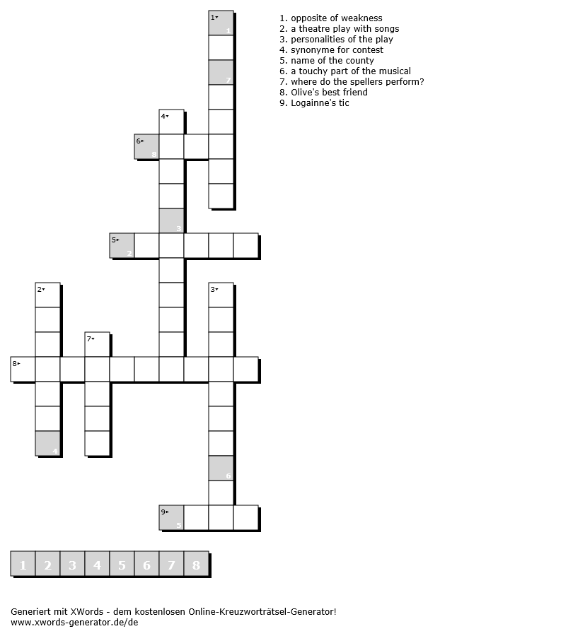
4. Fill in the gaps and find out the solution.

Answer Key

My favorite moment of the bee
(the song can be found on YouTube)

MR. PANCH Will the final two spellers please step forward.
MS. PERETTI Oh boy and Oh girl only two remain. I feel joy but I also feel pain
because I know what’s coming. Joy never comes for free. In a
moment he or she will enter spelling history, feeling triumph and glee.
In this moment of perfect syzygy I hear triumphant sounds of timpani.
It’s my favorite moment of the bee!
MR. PANCH Mr. Barfee, "Corzya."
WILLIAM Corzya.
MR. PANCH "Ilspile."
OLIVE Ilspile?
MR. PANCH Zoonosis. Chromatophore. Astrobleme.
OLIVE I'm loving every minute
WILLIAM Astrobleme.
OLIVE Who knew I had this thirst?
WILLIAM A-S-T
OLIVE To think that I might win it is astounding news and I'm about to burst
WILLIAM R-O astro
OLIVE How wonderful it feels to stand so close to first
WILLIAM B-L-E
OLIVE I'll make it happen and not as previously reckoned cause I will not come in
second! I hate to come in second. Yes I do! Yes I do! Yes I do! Yes I do!
I will not come in second.
WILLIAM M-E. Astrobleme
MR. PANCH That is correct. Miss Ostrovsky spell "Elanguescence"
WILLIAM Am I a Red Socks or a Yankee? Who will come in second? People are
scared of me and no one really likes me. I won't come in second. Hey Olive,
don't think I'm distracted by your eyes and your smile and your hairdo. Oh
the things I do not dare do; my fears are odious and fecund. You will not
outrank me. I won't wave my hankie. Second! I won't come in second! I won't
come in second! I won't come in second!
OLIVE I won't come in second. I won't come in second. I won't come in second.
Second. Elanguescence E-L-A-N-G-U-E-S-S-E-N-C-E? Elanguescence?
MR. PANCH For the win, William your word is: "Weltanschauung"
WILLIAM Yes of course, Weltanschauung. W...E...L...T..A...N...S..C..H..A...U-
CHORUS Who will come in…? Who will come in…? Who will come in…?
WILLIAM You
OLIVE I feel I'm in my glory
WILLIAM Should I come in second?
OLIVE Mama I made a friend
WILLIAM But should I come in second?
OLIVE I'll lose and that's the story,
WILLIAM Is second for me?
OLIVE But we are equals Ma where neither condescends
WILLIAM My fears are odious and fecund
OLIVE I am. I am fine with second. I can live with second. Yes, second. I will come
in second
WILLIAM And should I throw the bee? Could be checkmate any second.
Yeah, would I be happy second? If foe ever ever ever to always be stuck in
second. Will I come in second? Will I come in..? S-C-H-A-U
OLIVE It's alright, Barf.
WILLIAM U-N-G. Weltanschauung
MR. PANCH We have a winner!
CHORUS Champion!!
RONA Just sensational
CHORUS Champion!!
RONA Un-representational
CHORUS Champion! At the Putnam County Spelling
WILLIAM Thank you all very much!
CHORUS Bee!

